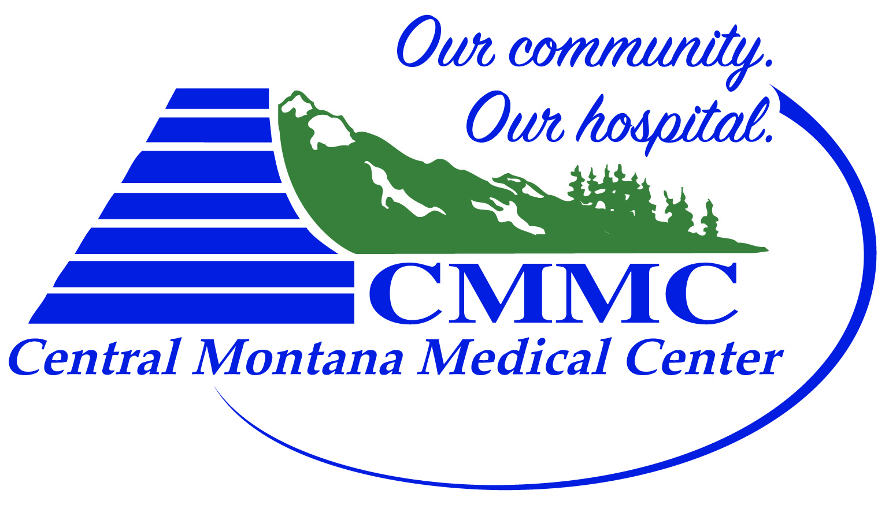
CMMC JUDITH PEAK REHAB
Central Montana Injury Prevention & Jump Training Program Registration Form
- Athlete Information
Name: | Age: DOB: | Circle: Male Female
T-Shirt Size:

- Parent Information (if under 18 years old)
Name:
Address | City |  | State | Zip
Email address |  | Phone

- Emergency Contact Name | Emergency Phone Number

- $150 for 18 Sessions – June 19th – July 31st, 2020
- Registration deadline: June 17th
- Sport:__________________________________

Checks payable to: CMMC
408 Wendell Ave,
Lewistown, MT 59457

