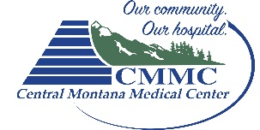

ATTENTION: MONTANA RESIDENTS BETWEEN AGES 19-64

Did you know there is now a new affordable health insurance plan available for Montana Residents ages 19-64* beginning January 1, 2016?
Does your income fall within these levels? Single person earning less than $16,243
Family of 2: less than $21,983
Family of 3: less than $27,724 Family of 4: less than $33,465 Family of 5: less than $39,206

Are you currently receiving benefits for any of the public assistance programs listed below?
Supplemental Nutrition Assistance Program (SNAP), also called Food Stamps
Women, Infants, and Children programs (WIC)
Subsidized/Low Income Housing Assistance
Low Income Energy Assistance Program (LIEAP)

If you answered “yes” to any of the above criteria, you may qualify for the new Montana HELP health insurance plan (Medicaid expansion). Central Montana Medical Center’s policy requires individuals to apply for the Montana HELP plan before being considered for financial assistance for medically necessary services.

To apply for the Montana HELP plan, use any of the following options:
Online at CoverMT.org or Healthcare.gov
Call 1-800-318-2596 (available 24 hours a day, 7 days a week)
If you qualify for the Montana HELP plan and are currently receiving a billing statement with a balance owed from Central Montana Medical Center, please complete the attached Central Montana Medical Center financial assistance application including the required documents. You may qualify for financial assistance for prior balances owed.
If you are denied eligibility for the Montana HELP plan, please provide proof of the denial and complete the attached Central Montana Medical Center financial assistance application including the required documents.
If you have answered “no” to the above criteria, please complete the attached Central Montana Medical Center financial assistance application. You may qualify for financial assistance.
- Have questions about insuring children under the age of 19? Please use one of the following options:
Online at dphhs.mt.gov/hmk
Call 1-888-706-1535 (Healthy Montana Kids helpline)
Financial assistance provided by Central Montana Medical Center under the Financial Assistance Policy is secondary to all Third Party Payers and other financial resources available to the patient. Examples include Medicaid and other federal, state or county medical programs.

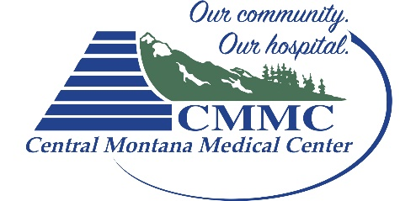
Financial Assistance Application

Clinic Account # Hospital Account #
You may apply for financial assistance for you and your family if you do not have health insurance, or are concerned that you may be unable to pay for all or part of your health care services.
We will work with you to see if you qualify for other health insurance programs, interest-free payment plan options, long-term loans, or our Financial Assistance Program. If you qualify for financial assistance, some or all of your balances may be reduced for medically-necessary services only. Central Montana Medical Center will determine if a service is medically necessary based on the Central Montana Medical Center’s Financial Assistance Policy, available at www.cmmccares.net or by calling a Patient Financial Representative.

1a. Household Information

Other members living in the household:
(Add more on another sheet of paper)
Home Phone: ( )
Cell Phone: ( )
Zip Code
State
City
Number and Street
Address:
Applicant:
Spouse:

First and Last Name Relationship Date of Birth

First and Last Name Relationship Date of Birth

1b. Are you currently receiving benefits for any of the public assistance programs listed below? If so, you may automatically qualify for Financial Assistance. Please provide proof with a current copy of confirmation of eligibility for one program (such as a letter of approval or copy of monthly coverage). Check the box for the program(s) you participate in:
Date of Birth: Social Security No.: Employer: Employer Address: Phone: ( ) Occupation: (Spouse) Date of Birth: Social Security No.: Employer: Employer Address:
Phone: ( )

Occupation: (You)
Marital Status: Single Married Divorced Widowed

First and Last Name Relationship Date of Birth
- Supplemental Nutrition Assistance Program (SNAP), also called Food Stamps
Women, Infants and Children programs (WIC)
Subsidized/low income housing assistance

Low Income Energy Assistance Program (LIEAP) State-funded low income prescription programs Homeless, or receiving care from a homeless clinic

First and Last Name Relationship Date of Birth
If you checked a box, skip to page 4 and sign part b. If not, go to page 2.

If you are not currently receiving benefits for any of the public assistance programs listed on page 1b, please complete the remainder of this form.

To be considered for financial assistance, you must supply the following:
Completed and signed application form
Copies of most recent year’s tax returns (federal and state), all pages and schedules, including W-2s
Copies of earnings statements for the applicant and his/her spouse for the last three (3) months (pay stubs, Social Security, unemployment, retirement, pensions, child support, federal student aid)
One copy of each of your last three bank statements – all pages
One copy of each of your last three pension/investment account statements (savings, CDs, stocks, etc.)
Letter explaining your need for financial assistance

Without the above listed items, your application could be denied as incomplete.
Please return this signed application and the above listed items within four (4) weeks. We will notify you in writing of our decision. You have the right to appeal our determination.

Income - List all monthly gross income | Applicant | Spouse | Other | Total
Gross wages from paycheck
Farm or self employed
Social Security/SSI/SSDI
Unemployment compensation
Workers compensation
Alimony
Child support
Pension/retirement
Income from dividends, interest, rent
Education grants/loans
Inheritance
Oil and mineral royalties/land lease
Native American income
Income tax refunds: federal state
Settlement income: worker’s comp. bodily injury lawsuit other motor vehicle accident
Other income (please explain)

Total

If you are currently unemployed, when was your last day of work?
Will you receive unemployment? Yes No
If you are temporarily out of work, do you expect to return to the same job? Yes No If so, when

Assets - Financial (Accounts I Own) | Current Balance | Financial Institution Holding Account
Checking account
Savings account #1
Savings account #2
CDs/bonds
Stock/mutual funds
Retirement funds
Other (Please List)

For internal use only

Total Assets
A + B1

Total Liabilities
B2 + C1

Total Monthly Payments B3 + C2 + D
Total

A
Assets - Property (Property I Own) | Current Value of Property | Amount Owed on Property | Monthly Payment (if loan associated with property)
House
Auto #1
Auto #2
Auto #3
RV
Boat
Motorcycle/ATV
Rental property
Other (Please List)
Total | B1 | B2 |  | B3

Liabilities (Balances I Owe) | Current Balance of Loan | Monthly Payment
Bank or credit union loans
Credit cards
Department store cards
Outstanding medical bills
School loans
Other (Please List)
Total

C2

C1

Monthly Expenses | Amount
Rent
Groceries/household products
Lights & heat
Phone (cell & home)
Water & sewer
Gasoline
Insurance (health, home, auto, life, renter’s, etc.)
Child care
Child support
Clothing
Entertainment including TV, internet, movies, etc.
Prescriptions
Other: (Please List)

Total

D

4a. Financial Assistance Application Check List

(For those filling out entire form)

Please be sure that you have answered all the questions on the application and included copies of required documents.

Did you and your spouse sign and date the application?
Did you enclose your most recent tax returns (federal and state), all pages and schedules, including W-2s?
If you did not enclose a copy of your tax returns, why?
Did you enclose copies of your earnings statements for the last 3 months?
Did you enclose copies of all award letters for unemployment, financial aid for college, or general assistance?
Did you enclose a copy of your Social Security check or copy of award letter?
Did you enclose a copy of each of your last three bank statements?
Did you enclose a copy of each of your last three pension/investment account statements (savings, CDs, stocks, etc.)?
Did you write a letter explaining your need for financial assistance?

4b. Release of Information Authorization for Financial Assistance
(For ALL Applicants)
I certify that the information I provided is true and correct to the best of my knowledge. I will cooperate to obtain assistance and pay Central Montana Medical Center any money I receive.
I will provide Central Montana Medical Center with information about any other means to pay this bill such as Medicaid, Crime Victims Fund, automobile or home insurance policies, etc. I will cooperate with Central Montana Medical Center to apply and obtain assistance from any government agency that I am qualified to receive assistance from and will pay Central Montana Medical Center any money I receive relating to these medical services.
I authorize Central Montana Medical Center to contact employers, financial institutions, state and federal agencies, and other third parties to verify the information I have provided or to obtain additional information regarding my finances. I authorize any such entities to provide information to Central Montana Medical Center about my current assets, liabilities, credit, and other information as reasonably requested.
I release Central Montana Medical Center and its representatives from any and all liability connected with this release of information. Please check the name of the facilities where you have an outstanding balance to be considered with this application:
Central Montana Medical Center Central Montana Medical Center Clinic
CMMC Home Health/Hospice CMMC Home Oxygen & Medical Equipment

Signature of Applicant Date
(Patient, Parent or Guardian)

Signature of Spouse Date
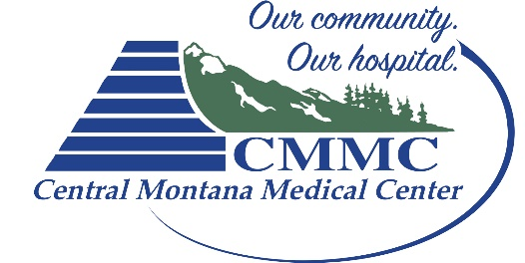
Mailing Address:
Central Montana Medical Center
408 Wendell Ave
Lewistown, MT 59457

