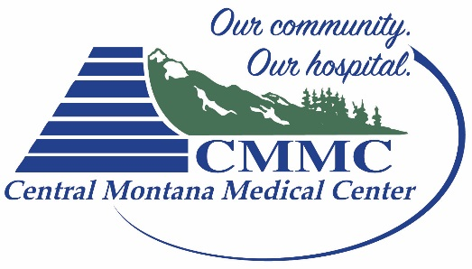
CMMC JUDITH PEAK REHAB

ACKNOWLEDGEMENT OF RESPONSIBILITY AND INFORMED CONSENT
I, _____________________________________, would like my child to participate in
(name of parent or guardian)

Central Montana’s Injury Prevention & Jump Training Program at CMMC Judith Peak Rehab. I understand that this activity entails a risk of injury, and that when young people are engaging in sports performance training or testing, accidents can happen even when there is supervision. I know that my child and I bear some responsibility for minimizing the risk of injury. I will talk with him or her about the importance of safe behavior.
- HEALTH NEEDS. My child has no health related condition or disability that limits his or her ability to participate in the program or activity, except as follows:
_______________________________________________________________________
_______________________________________________________________________
_______________________________________________________________________

- EMERGENCY. In case of medical emergency occurring while my child is participating in a program or activity, I authorize CMMC, in advance, to secure whatever treatment it deems necessary. CMMC may take such actions as it considers to be warranted under the circumstances for my child’s health and safety. I agree to bear the expense for any emergency medical treatment and release CMMC from liability for the same.
- RULES AND REGULATES. I have directed my child to listen and be mindful of all safety instructions provided to him or her, and to abide by all programs rules.
- BEHAVIOR. CMMC reserves the right to remove or restrict a child who does not listen to instructions, engages in bullying, hostile behavior, or other actions that interfere with the conduct of the program.
I HAVE READ THIS ACKNOWLEDGEMENT. I UNDERSTAND AND ACCEPT IT.
Dated: _____________________ ________________________________________
(Child’s name and date of birth)

Emergency Contact: ___________________________________________________________
(Name) (Phone #)

Parent/Guardian Signature: _____________________________________________________

