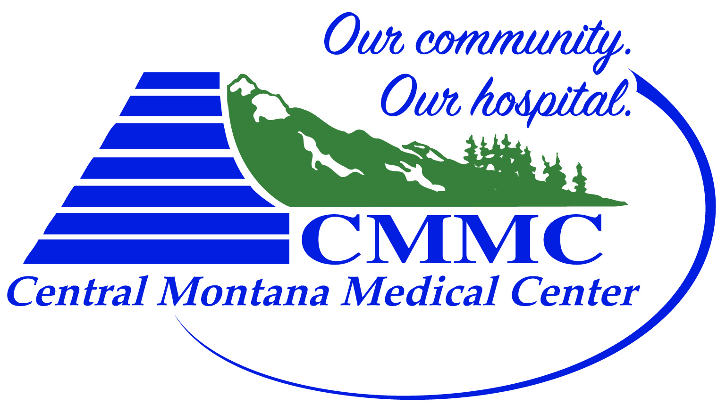
CMMC JUDITH PEAK REHAB
Central Montana Injury Prevention & Jump Training Program Registration Form
- Athlete Information
Name: | Age: DOB: | Circle: Male Female

- Parent Information (if under 18 years old)
Name:
Address | City |  | State | Zip
Email address |  | Phone

- Emergency Contact Name | Emergency Phone Number

- $150 for 18 Sessions – June 4th – July 13th, 2018
- Registration deadline: June 1st
- Sport:__________________________________
- College:________________________________

Checks payable to: CMMC
408 Wendell Ave,
Lewistown, MT 59457

