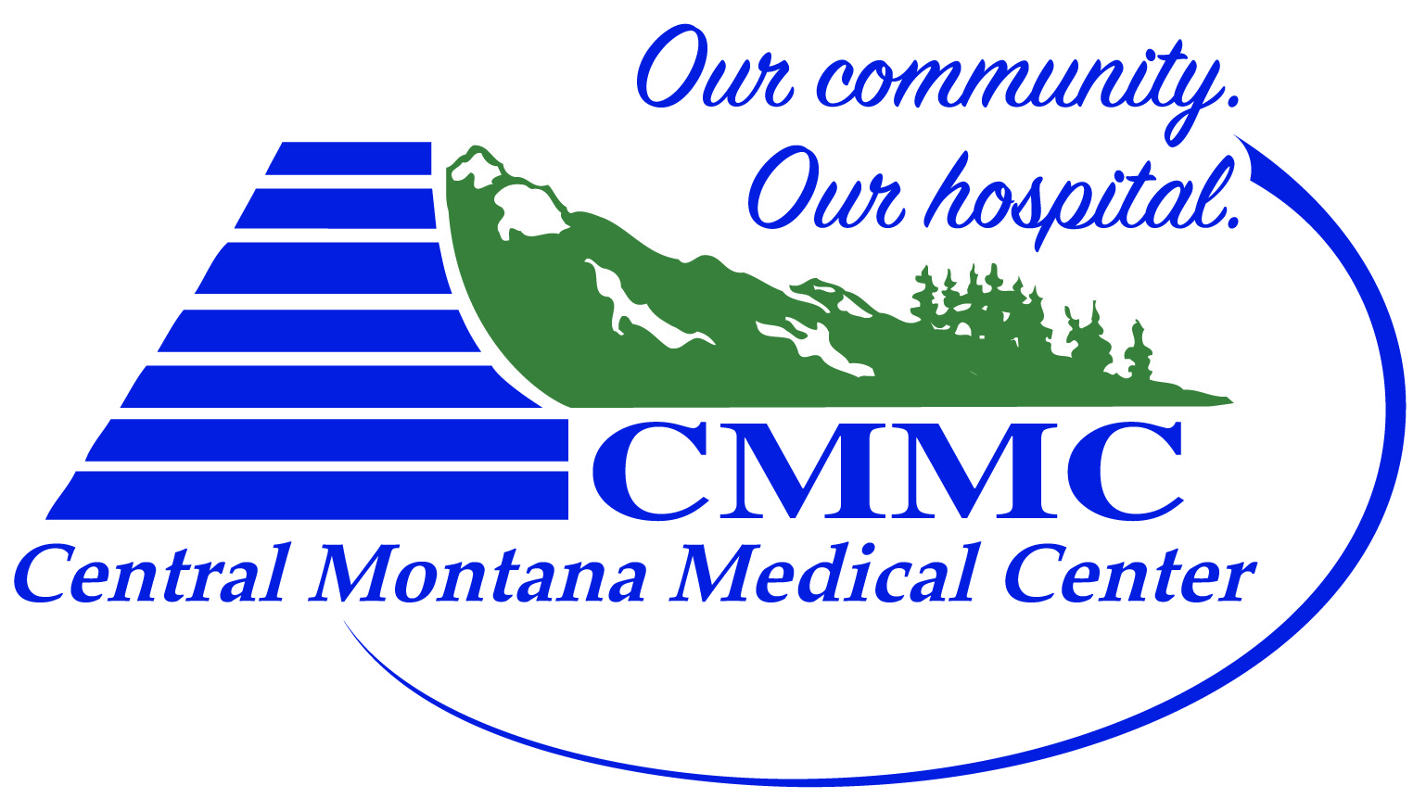

Judith Peak Rehab
Jump Training Application Question
- What are you expecting to get out of this Jump Training program?

- What are your goals for the rest of your high school/collegiate athletic career?

- Do you have post-high school athletic goals? If so, what? If you’re a collegiate athlete- do you have sport specific collegiate goals set?

- Define what mental strength means to you.

- Define what work ethic is to you.

- How do you stay focused? (during competition, the off season, or during a test?)

- How do you stay confident during challenging times?

- How do you keep your confidence when you are at the top of your game?

- Greatness. What will it take to be great? (At anything)

CMMC Judith Peak Rehab
Injury Prevention Through Evidence Based Jump Training
The application process for the CMMC Judith Peak Rehab Jump Training Program will include completely filling out each form:
- Central Montana Injury Prevention & Jump Training Program Registration Form
- General Assumption of Risk & Release of Liability
- Acknowledgement of Responsibility and Informed Consent
- Jump Training Application
- $150 to Central Montana Medical Center

Other considerations:
To maintain high level of one-on-one feedback, only 6 spots are allotted for this program. If more than 6 athletes apply, we will utilize the Jump Training Application short answers to hand pick athletes who best suit the program. If this occurs names will be blacked out on the application to eliminate bias.

