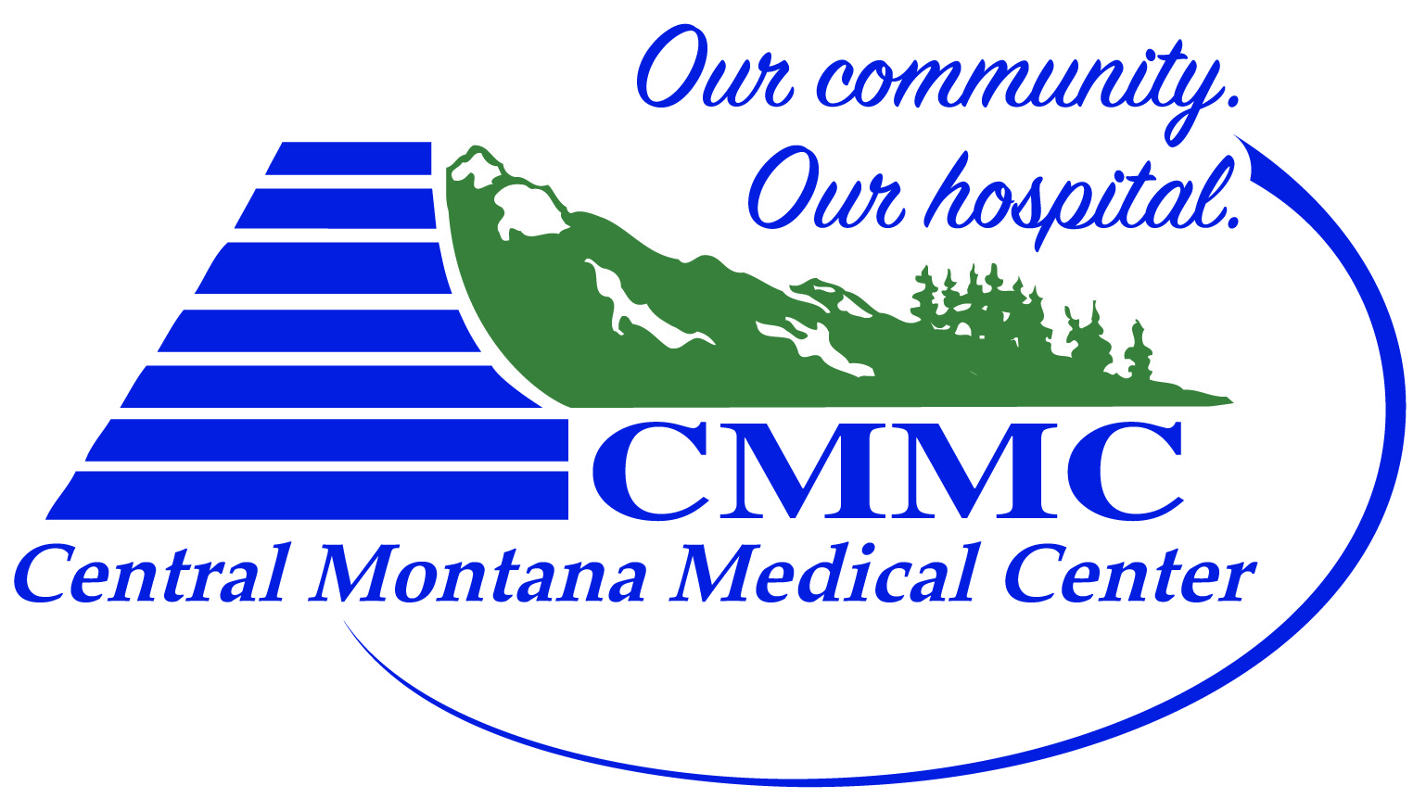

GENERAL ASSUMPTION OF RISK & RELEASE OF LIABILITY
CMMC is a non-profit Critical Access Hospital.
I ____________________________________________________, freely choose to participate in the Central Montana Sports Enhancement Program. In consideration of my participation in this program, I agree as follows:
RISKS INVOLVED IN PROGRAM (Inherent in this program’s activity)
Bodily injuries resulting from exercise training or testing in a sports performance clinic setting involving speed and agility training, plyometrics, and resistance training exercises.
I recognize that the above specifications are not complete and that participation in the program could lead to consequences which are not anticipated.
I understand that participation in this program is voluntary and I may withdraw at any time. I understand that participation may or may not actually benefit me.
HEALTH AND SAFETY: I have been advised to consult with a medical doctor regarding any personal medical needs. There are no health-related reasons or concerns that preclude or restrict my participation in this program, except as stated here:
______________________________________________________________________________________________________
______________________________________________________________________________________________________

I have obtained any required immunizations.

In case of a medical emergency occurring during my participation in this program, I authorize in advance, CMMC to secure whatever treatment is deemed necessary. CMMC and FHS may (but is not obligated to) take any actions it considers to be warranted under the circumstances for my health and safety. I agree to pay all expenses for such medical treatment and I release CMMC and FHS from any liability.

ASSUMPTION OF RISK AND RELEASE FOR LIABILITY: Knowing that participation in this program entails some risks, and in consideration of being permitted to participate in the program, I agree to release CMMC and FHS from any and all costs, claims, injury or illness resulting from my participation in the program, other than for CMMC’s and/or FHS’s intentional misconduct or gross negligence.

I accept the program rules and regulations. I have been advised that I should look to my own health insurance policy in case of injury. I have read and fully understand this document. All blank spaces were filled in and/or sections crossed out prior to my signing.

Date: ______________________

Participant Signature: _____________________________________________________

Parent/Guardian Signature: ________________________________________________
(If under 18 years of age)

