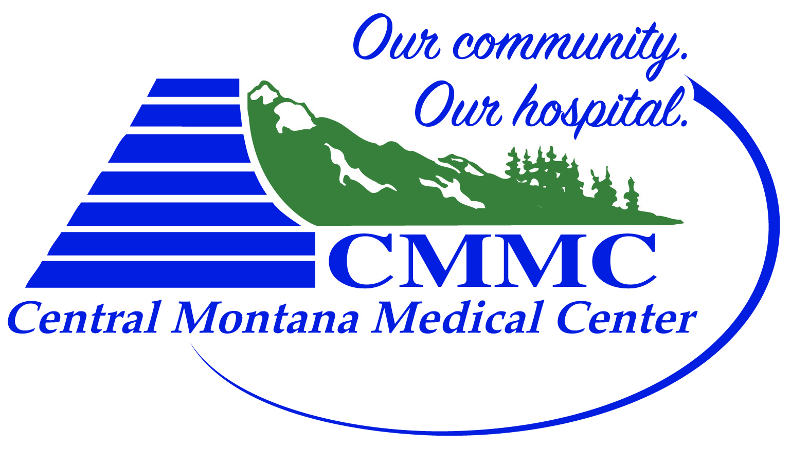
Central Montana Sports Enhancement Program Registration Form
- Athlete Information
Name: | Age: DOB: | Circle: Male Female

- Parent Information
Name:
Address | City |  |  | State | Zip
Email address |  |  | Phone
Emergency Contact Name |  | Emergency Phone Number

- $150 for 1st child, $100 per additional child; 17 Sessions – June 4, 2018 to July 13, 2018
- Registration deadline: June 1, 2018

Checks payable to: CMMC
Judith Peak Rehab
408 Wendell Ave,
Lewistown, MT 59457

