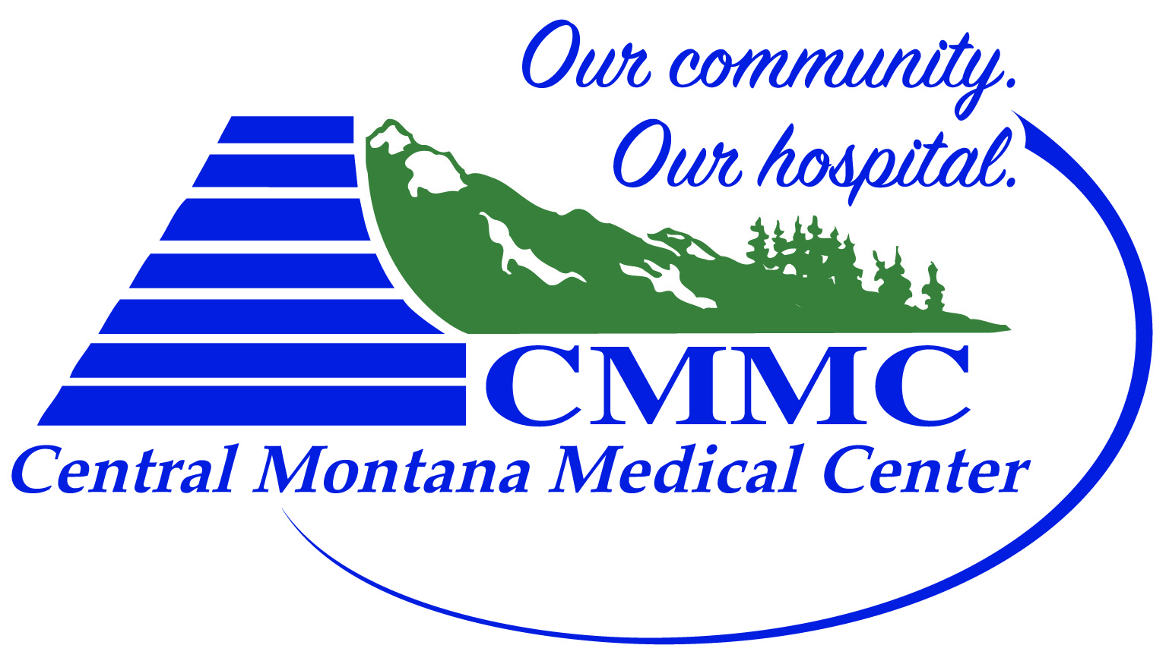
Central Montana Sports Enhancement Program Registration Form
- Athlete Information
Name: | Age: DOB: | Circle: Male Female

- Parent Information
Name:
Address | City |  |  | State | Zip
Email address |  |  | Phone
Emergency Contact Name |  | Emergency Phone Number

- $150 for 1st child, $100 per additional child; 17 Sessions – May 29th – July 9th, 2018
- Registration deadline: May 25th

Checks payable to: CMMC
Basin Therapy
215 3rd Street South
Stanford, MT 59479

